Step 1

Go to google developer console – Search google developer console

Step 2

Click on Enable APIs and Services

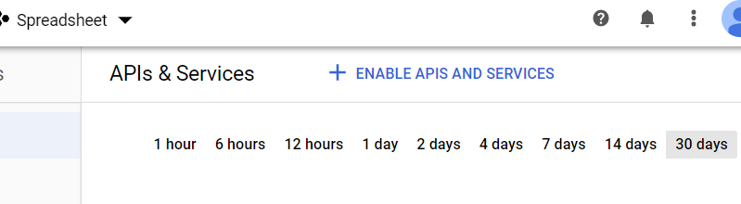

Step 3

Search for Google Drive & Google Sheets API in search bar. Click on it.

Step 4

Click Enable/Manage (Cause I already enabled in this case)

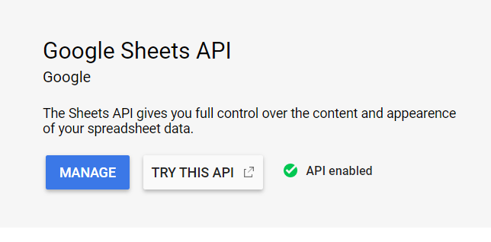

Step 5

After enabling it, on the left-hand side, click on credentials tab, click create credentials. Then click on create service account.

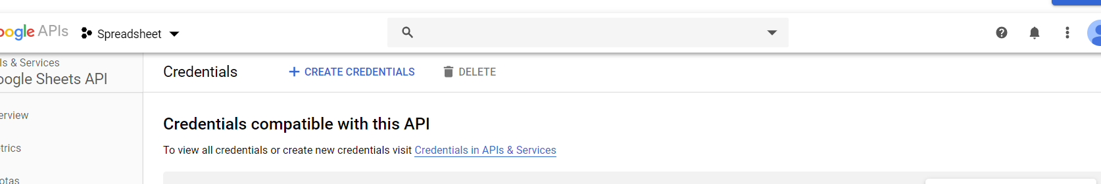

Step 6

Key in whatever name you want, then click on create.

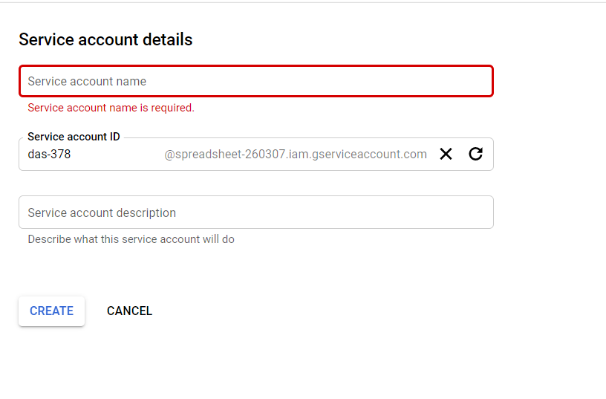

Step 7

For permissions, select Editor/Owner under Project tab.

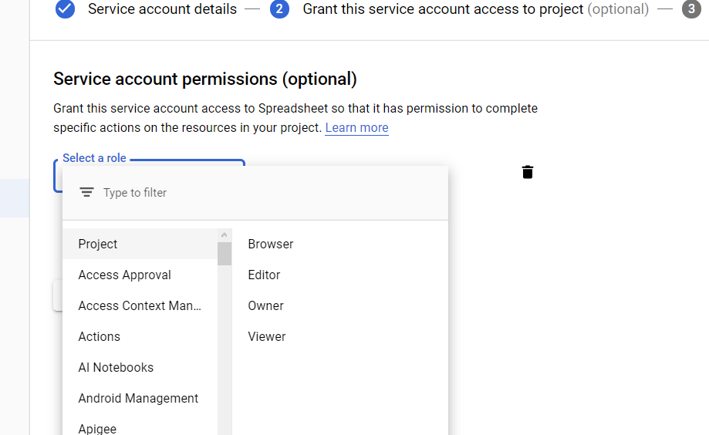

Step 8

When done, copy the service account email from the main dashboard, then go to your google sheets and share the google sheets with this email.

